Name: Shreyash Patil

PRN: 22510039  
Batch: T3

Assignment 7 ADS

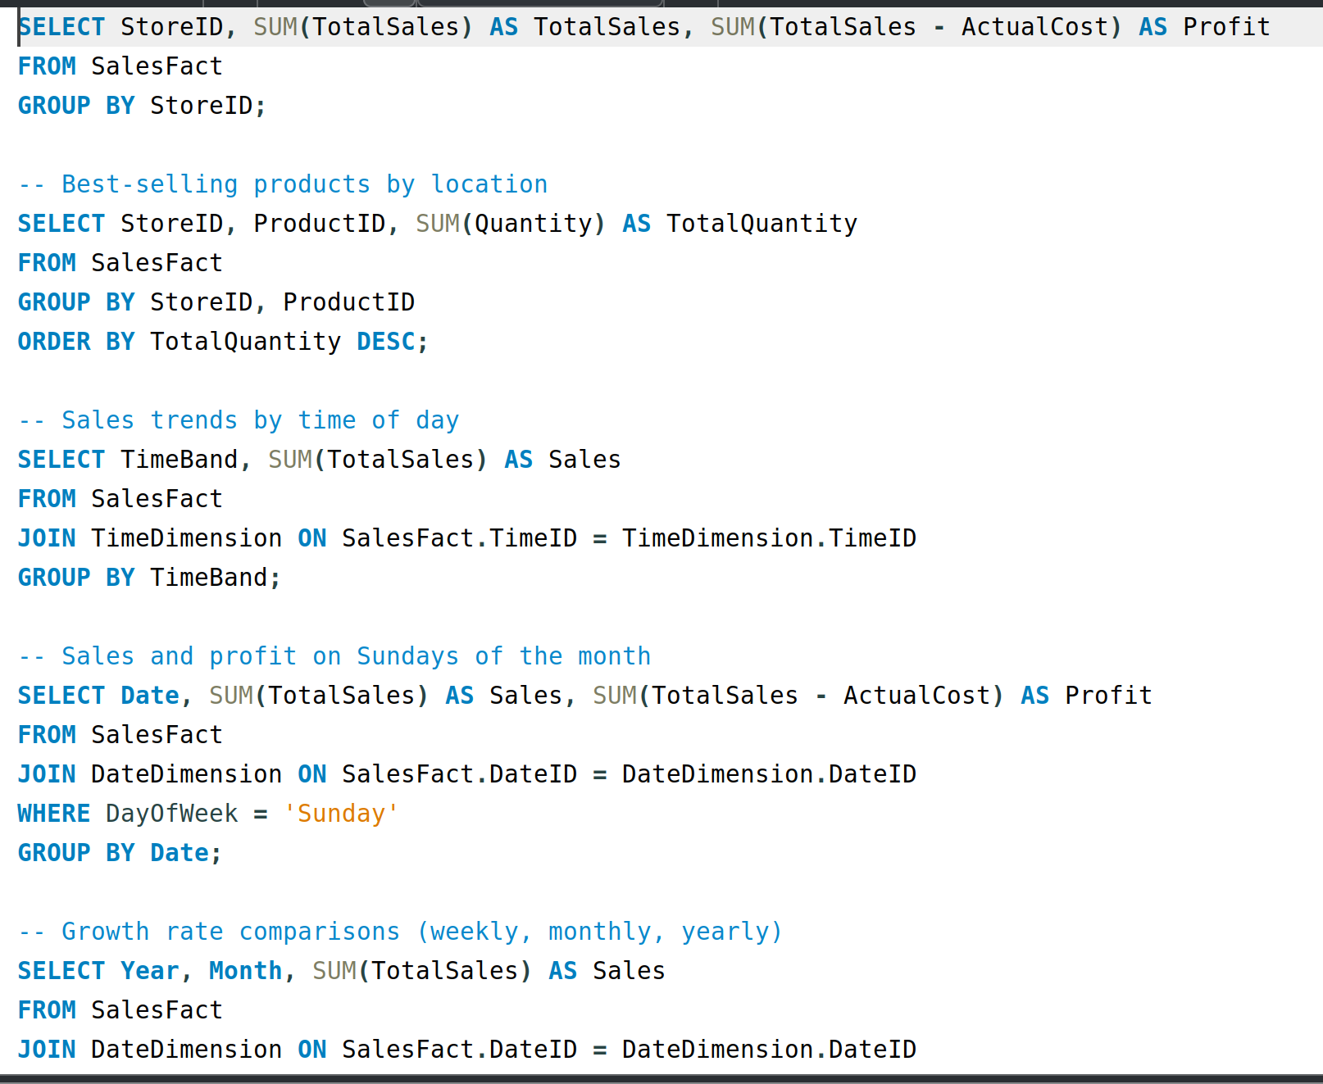  
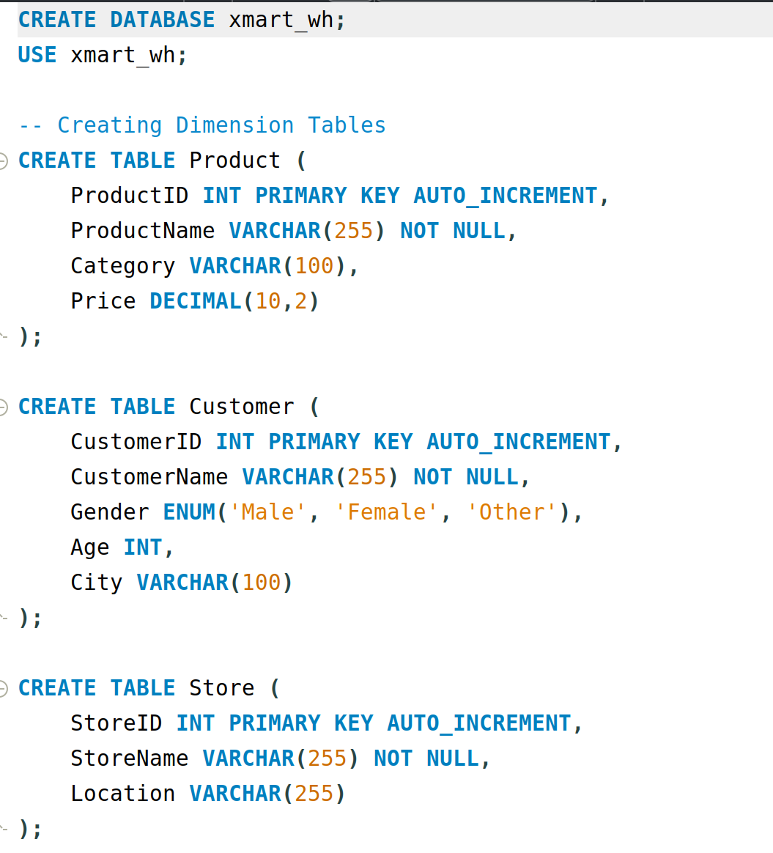  
This has the star schema